

**CITY OF HOLLYWOOD RETIREES ASSOCIATION – 2023 Form**

**MEMBERSHIP APPLICATION/RENEWAL**

CALENDAR YEAR

PLEASE ATTACH CHECK FOR **$20 ANNUAL FEE**

FULL NAME

MAILING ADDRESS

EMAIL

PHONE

*Designates Optional Information

*We need your help:* ***Renewals are effective January 1st*** *and we don’t charge late fees, so please renew it on time. Just mail in the $20 check and this form to our address:*

CITY OF HOLLYWOOD RETIREES ASSOCIATION

P.O. Box 814778

Hollywood, FL 33081

*If you have any questions, contact us at* [*flbobcat@aol.com*](mailto:flbobcat@aol.com)

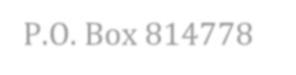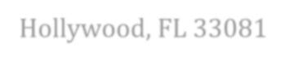

COHRA - CITY OF HOLLYWOOD RETIREES ASSOCIATION

P.O. Box 814778

Hollywood, FL 33081

[http://cohrafl.org](mailto:flbobcat@aol.com)